Final Project: Pick a Project
Computer Science - Week 10
Oct 3, 2026 - Version 0.0.2
Please make sure to your UD email AND name is below. Unless your UD emails are included in this table, then you will not earn any points for this assignment when it is graded! Every person should submit their own individual worksheet.

Talk about each of the questions with a friend or our LLM (or both), but make sure the words you enter below are yours (with the obvious exceptions notwithstanding). Brainstorming is best done in full sentences, and the main goal here is brainstorming. It's worth reviewing the information in this series of pages in the Drafter documentation to gain a better understanding of the process.

Role | Name | Email
Developer (You) | Gabriel Young | gyoung@udel.edu
Friend (optional)

Part 1: The Goal & Prior Implementations
- Identify the Goal: What specific goal are you trying to address? Think about your passions, hobbies, and academic interests. The latter are an excellent candidate to focus on. Some majors have suggestions listed below: these were provided by faculty in those departments. Other majors could consider a focus tied to a big final assignment in one of their recent courses in their major.
  - Biomedical Engineering majors may consider one of the following:
    - If you have started (or completed) the Cell/Tissue Design final project in BMEG100, design an organoid, which involves combining a cell type, biomaterial, and testing method. Have the website include a description and diagram of your design concept, a testing method, a needs statement, and an impact statement relevant to their organoid. Also include a link to a paper that supports your idea and a paragraph describing how that paper supports your design concept.
    - Otherwise, create a website related to your BMEG100 Lab Report 1, Cytoskeletal and Nuclear Staining Lab Report Guidelines, linked here (University of Delaware account required to access).
  - Chemistry and Chemical Engineering majors may consider creating an automated chemistry assistant that takes balanced reaction equations, starting reactant masses, and a harvested product amount to determine the limiting reactant, theoretical yield, and percent yield based on principles from Chemistry 2e (OpenStax) — Chapter 4: Chemical Reactions and Stoichiometry. To avoid manually compiling atomic mass tables or writing custom string tokenizers, use the ChemPy library to parse molecular formulas into exact molecular weights and verify reaction stoichiometry against compound data from the NIH PubChem Database. The program outputs an organized breakdown of limiting reagent status, product yields, and remaining masses of unreacted species. Also use the heat of the reaction to determine if it is exothermic or endothermic, and compute the heat flow per mole of the product.
  - Majors in the Electric & Computer Engineering department may consider a steganography project that hides messages in images, and then retrieves those messages from uploaded images.
  - Mechanical Engineering majors may consider a project that somehow uses both the NumPy and SciPy Python libraries.
When it comes to writing music, for me and likely for many other composers, it can be a little daunting. We often think we have to write an entire piece whenever we sit down to compose, leading to many composers not actually composing. If composers aren’t composing, the world is robbed of music. However, if people sat down with the expectation to write only a snippet of music, they would be way more likely to sit down and compose! So, I propose to have a website that gives composers a daily set of measures to compose in without getting too intimidated. The website could also have daily challenges/limitations for the composer’s music for the day, which could also inspire them!

- Prior Implementations: Search the internet. What existing tools or websites currently attempt to address it?
There are already music writing softwares like musescore, and even web-based composing software like Noteflight and FreeNotation. There is also Melodiee, the closest software to addressing this problem, as it is tailored to capture spontaneous music ideas.

- Your Implementation: Briefly describe the legitimate purpose or functionality of your site. How would you want this web application to be used?
I would want my site to be a place for composers to visit daily and take 30ish minutes to write a blurb of music. They could maybe share their music blurbs with friends and strangers, and save their blurbs to come back to if they ever want to elaborate on them.

Part 2: The Input-Process-Output (IPO) Model
Think about the fundamental flow of your program.
- The Core Goal: Every program has three main phases: taking input, processing data, and presenting output. In one sentence, what is the ultimate goal your program will accomplish for the user? Be specific and use CS1 concepts.
The main input for my program would be the score function, which would respond to users clicking on the staff to place music notes. I could also see there being a piano pop-up to place notes on the staff; each piano key would be a button for a different note. However, the program ultimately wants to store a user’s musical input for them playback, sharing with friends, or to reference later.

- Input: What specific information will the user need to provide to your program? (e.g., a city name, a numerical budget, a list of hobbies).
What notes they want on the staff, what pitches they want the notes, and how many measures they would like to write (either 4, 8, 12, or 16 max).

- Processing: At a high level, how will the computer manipulate or evaluate that data? (e.g., calculate the average, filter out options that are too expensive, compare the input against a database).
My music snippet program would compare user inputs to a list of pitches, as well as a list of note lengths in order to get the user’s desired note. It would also store collections of notes and rests in each measure to be referenced later to be listened to, or to be edited further. As well, the program would randomize a specific challenge for the user’s snippet that day(such as only using eighth notes and rests) and restrict the user based on that challenge.

- Output: What will the user get back? (e.g., a recommendation, a calculated safety factor, a formatted schedule).
The user will mostly get back audio from individual notes and if they pull up an entire music snippet an extended audio, as well as the visual of the staff with notes on it.

Part 3: Data Abstraction
Identify the "nouns" of your problem.
- Representing Reality: Abstraction is the process of representing the real world inside a computer by ignoring unnecessary details. What are the core "things" (nouns) your program needs to track? (e.g., If building a recipe app, the nouns are "Recipe" and "Ingredient").
I would need to keep track of Notes, Measures, Music Snippets, Rests, for the basic composing function. I would also need to keep track of a Challenge that would restrict what the user could write.

- Identifying Properties: For the most important "thing" you listed above, what 3 to 4 specific details do you actually need to solve your problem, and what details will you abstract away?
  - Details I need: (e.g., Ingredient name, weight, cost)
  - Details I will ignore: (e.g., Ingredient color, brand, expiration date)
For the Notes, which are the building blocks for music, I would need to know the Note’s pitch, its length/duration, the beat it starts on within the measure, and whether it’s an accidental or not(flat, sharp, or natural). If I want to keep this program relatively simple and beginner friendly, I may ignore more advanced music notation such as note articulation, crescendos and decrescendos.

Part 4: Challenges, AI Strategy, & Goals
- Difficulties: What parts of this project seem the most difficult or technically complex?
This project’s focus on audio will definitely make it tricky to execute, since drafter is not known for its audio capabilities.

- Coding Strategy: If you will be using an LLM to help code, how will you ensure you understand the generated code and avoid "hallucinations" or "shallow learning" (copying without understanding)? If you won't be using an LLM to help code, this project might take about 4 hours a week to complete, so list each of the days and times in which you work on the project.
Ideally, I will use little to no AI assistance for coding my project, and plan to work on the project every Tuesday and Thursday from 2pm - 4pm. However, if something ends up stumping me, I may ask AI some questions or give parts of my code to see what it points out. If something ends up being completely unreasonable for me to accomplish due to complexity or time constraints, I will use AI code as a last resort. If this happens, I will trace through the AI code to and give it my own docstrings in order to ensure I understand it.

- Goals: What is your ultimate goal for this project? (e.g., Impress the graders with a creative UI, build something I can use in my other classes, learn Drafter deeply).
I have two goals for this project. First, I would like to create something I could go to daily, like Wordle, for writing music. Second, I would like to have a non-game computer science project to put on my portfolio for any computer science positions I may apply to in the future.

Part 5: Research & Brainstorming Conversation
Have a conversation with a Generative AI tool (like ChatGPT or Claude) OR a friend about your project idea. Do not ask for code. Instead, use the AI/friend as a sounding board to research your problem.
- The Initial Prompt/Question: Ask the AI or your friend to help you brainstorm. (e.g., "I want to build a simple web tool to help students track their study hours. What are 3 common problems students face when tracking their time, and what are 3 simple features a basic tool should have?"). Paste your prompt below:
I'm looking to create a website where composers can write small chunks of music as a daily challenge, in a somewhat similar fashion to Wordle. What can I do to help make music composition less intimidating and daunting, and lighter and more fun?

- The Response: Briefly summarize the best ideas the AI or your friend suggested. What existing solutions or prior apps did they mention?
ChatGPT suggested that basing my program off of Wordle’s low commitment style would be a great way to encourage people to compose. It also suggested having multiple daily challenge categories like technical challenges, instrumentation challenges, and emotional challenges, to allow both experienced and amateur composers different options that best suit their needs. Lastly, it emphasized that I could ‘reskin’ different music theory concepts in my program to simpler terms in order to help newer composers learn music theory without it feeling like homework.

- The Pushback: You must reply to the AI/friend to narrow the scope when it's over-ambitious. Pick the most complex feature they suggested and explain why it is too complicated for an introductory programming project. Ask them for a simpler alternative. Paste your response here:
While I do think it would be a wonderful idea to allow users to save their short music compositions, I am a beginner computer scientist and will be using Drafter for this program; which I'm not sure has such data saving capabilities, especially across multiple instances of pulling up the program. How would you simplify or change this mechanic to make it more technically accessible while still allowing people to save or keep their music snippets?

- Reflection: Based on this conversation, how has your project idea changed or become more focused?
First, this conversation has made me want to give my music composition Wordle program a more educational spin, as I think music theory can be quite hard to get into for folks just starting to learn. Additionally, the AI gave me a really good suggestion for circumventing the technical difficulties for saving people’s music compositions by instead letting them download compositions instead, a feature that Drafter can actually support.

Part 6: Resource Planning
- What resources will you use if you get stuck?
I will use a combination of the Drafter notion site, TA office hours, CISC108 discord server, and potentially some AI conversations.

- If your LLM provides code that causes a Drafter or Bakery error, or if you run into a problem during deployment, what is your step-by-step debugging plan to resolve it?
- Read the error message to determine what might be going wrong.
- Trace the code to see if an error becomes apparent.
- Isolate parts of the code via commenting out to see what works and what doesn’t.
- Consult Drafter notion
- Delete/comment out the entire code and try to reconstruct it myself.
- Move on to another part of the program and come back to the problematic code another time.

Part 7: LLM Conversation
If you used an LLM in any part of this work, copy and paste every part of that conversation below. Otherwise, you may be given a zero for the assignment. Obviously, these words will not all be yours, and this is the exception to the requirement at the top of this assignment that all responses be in your own words. If you did not use an LLM to assist you in this assignment, simply say so below. (Highlighted Text is my own words)
I'm looking to create a website where composers can write small chunks of music as a daily challenge, in a somewhat similar fashion to wordle. What can I do to help make music composition less intimidating and daunting, and lighter and more fun?
I love this idea! There's a really interesting opportunity here because music composition can feel much more intimidating than writing a few words, especially for people who haven't studied music theory extensively.
I think the key is to borrow what makes Wordle so appealing: low commitment, clear constraints, a little bit of discovery, and the satisfaction of creating something every day.
I'd approach your website less as a traditional music composition tool and more as a daily creative playground.
Here are some ideas I'd consider.

1. Make the challenges small and approachable
One of the biggest barriers to composition is the feeling that you need to create something complete, polished, or impressive.
Your website should actively challenge that expectation.
Instead of asking users to compose an entire song, ask them to create something tiny.
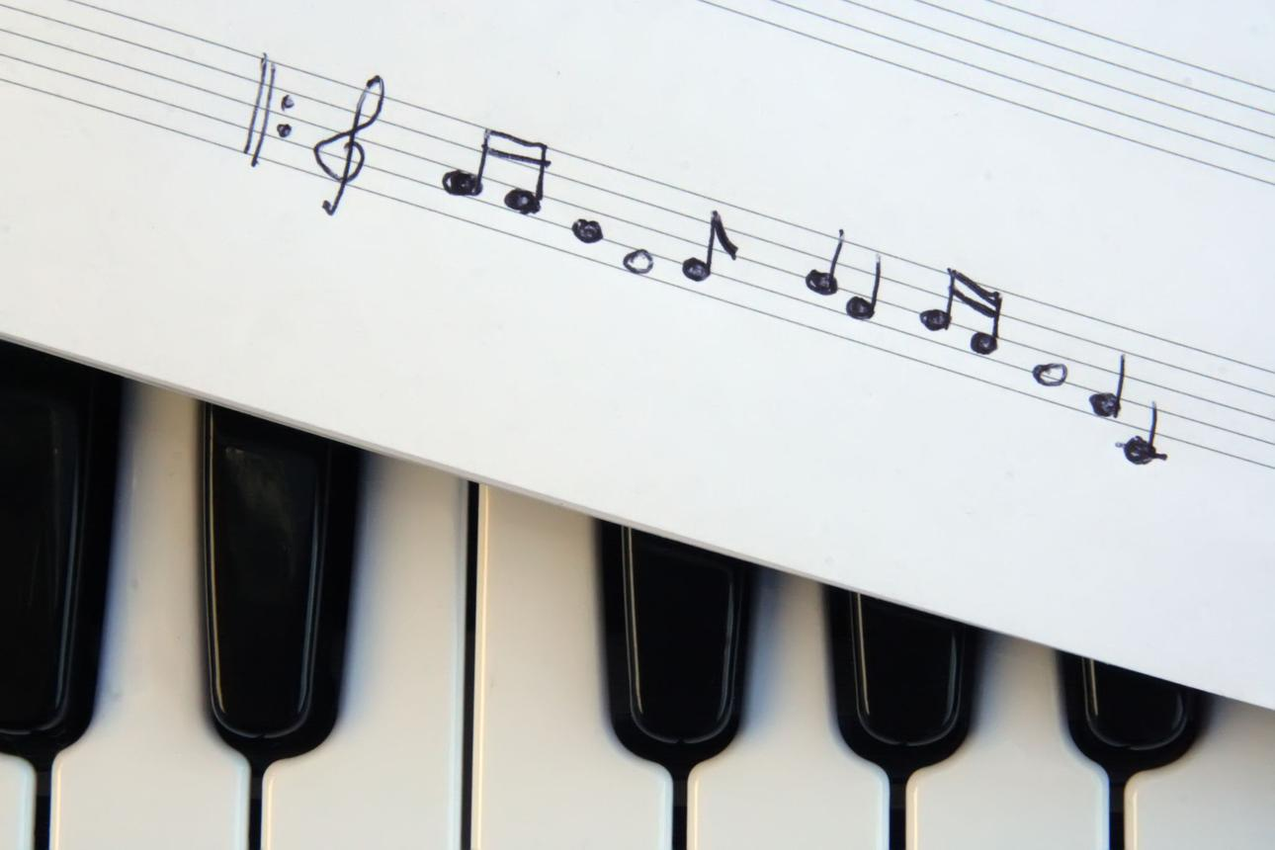
The 5-Note Challenge
Create a melody using only five different notes.
Beginner friendly
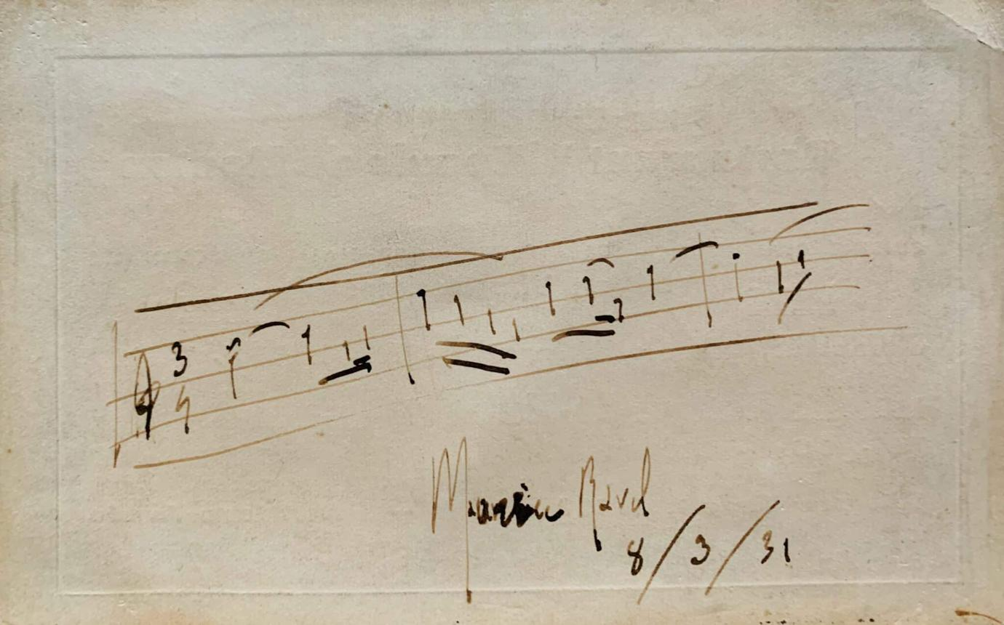
The 4-Bar Challenge
Write a musical idea that is exactly four measures long.
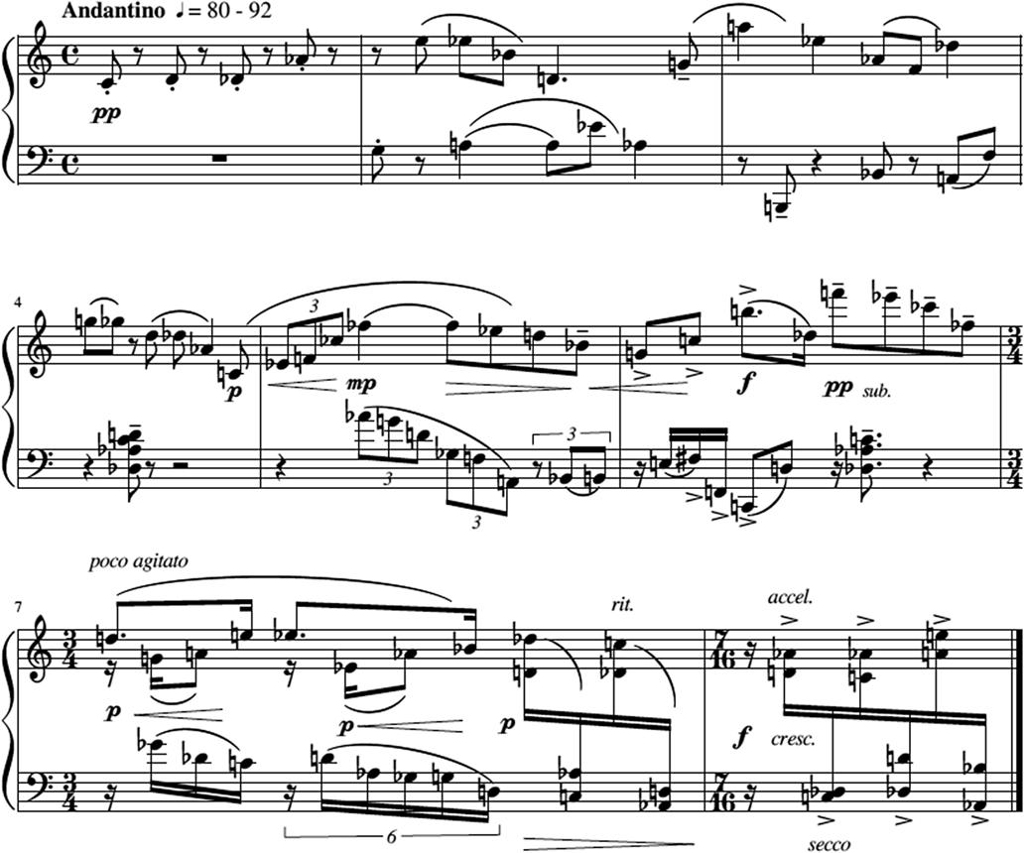
The Emotion Challenge
Compose something that sounds like the feeling of waking up on a rainy morning.
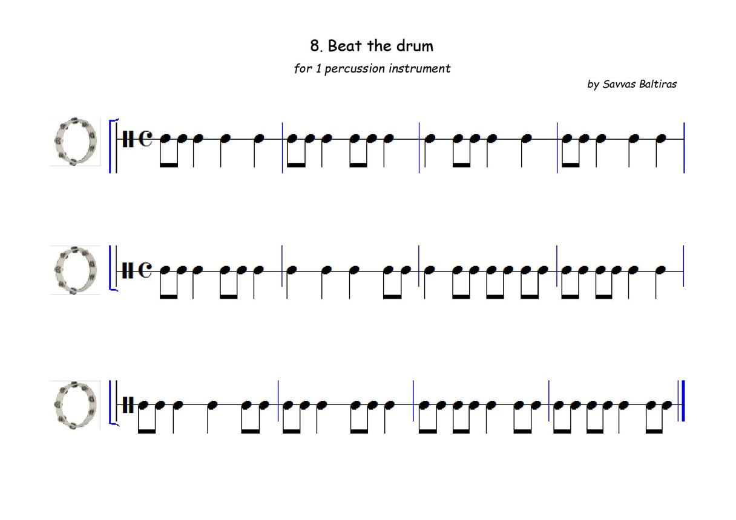
The Rhythm Challenge
Create a recognizable rhythm using only three different rhythmic values.
The important thing is that users should feel like they can finish a challenge in 5–15 minutes.

2. Use constraints to encourage creativity
This is probably one of the most important design decisions you can make.
A blank sheet of music is intimidating. A sheet of music with a few restrictions can be exciting.
Give each daily challenge a handful of creative constraints.
For example:
Daily challenge #001
Example challenge

A Little Bit of Nostalgia

Your mission: Write a short melody that feels nostalgic.
Your constraints
- Key: C major
- Length: 4 measures
- Tempo: 80–100 BPM
- Instrument: Piano
- Include at least one repeated note.
There is no wrong answer. Interpret nostalgia however you like.
You could even randomize some of the constraints:
- Instrument
- Key signature
- Time signature
- Tempo
- Number of notes
- Musical mood
- Rhythmic pattern
- Dynamic markings
This creates a fun puzzle-like experience without making composition feel like homework.

3. Make music theory optional
This is especially important if you want to attract people who are interested in composing but don't necessarily have formal musical training.
Avoid making users feel like they need to understand:
- Chord progressions
- Functional harmony
- Counterpoint
- Modes
- Advanced rhythmic notation
- Music theory terminology
Instead, translate musical concepts into approachable language.
Traditional terminology | Friendlier language
Staccato | Short and bouncy
Legato | Smooth and connected
Crescendo | Gradually get louder
Ostinato | A repeating musical idea
Syncopation | Unexpected rhythmic accents
Dissonance | Notes that create tension
You can still teach theory, but it should happen naturally through experimentation.
A great philosophy would be: let users discover musical concepts before asking them to learn their names.

4. Introduce playful challenge categories
Not every challenge needs to focus on technical composition.
I'd create different categories to keep the experience fresh.

Creative challenges
Compose based on a feeling, image, memory, or story.
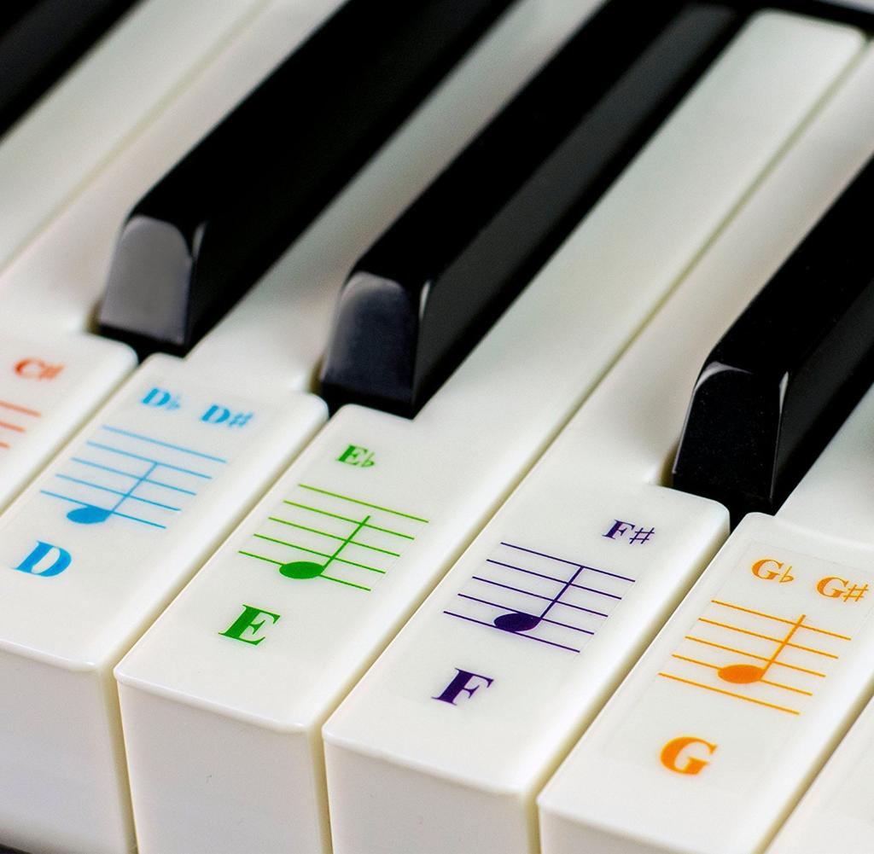
Technical challenges
Experiment with scales, rhythms, intervals, and restrictions.
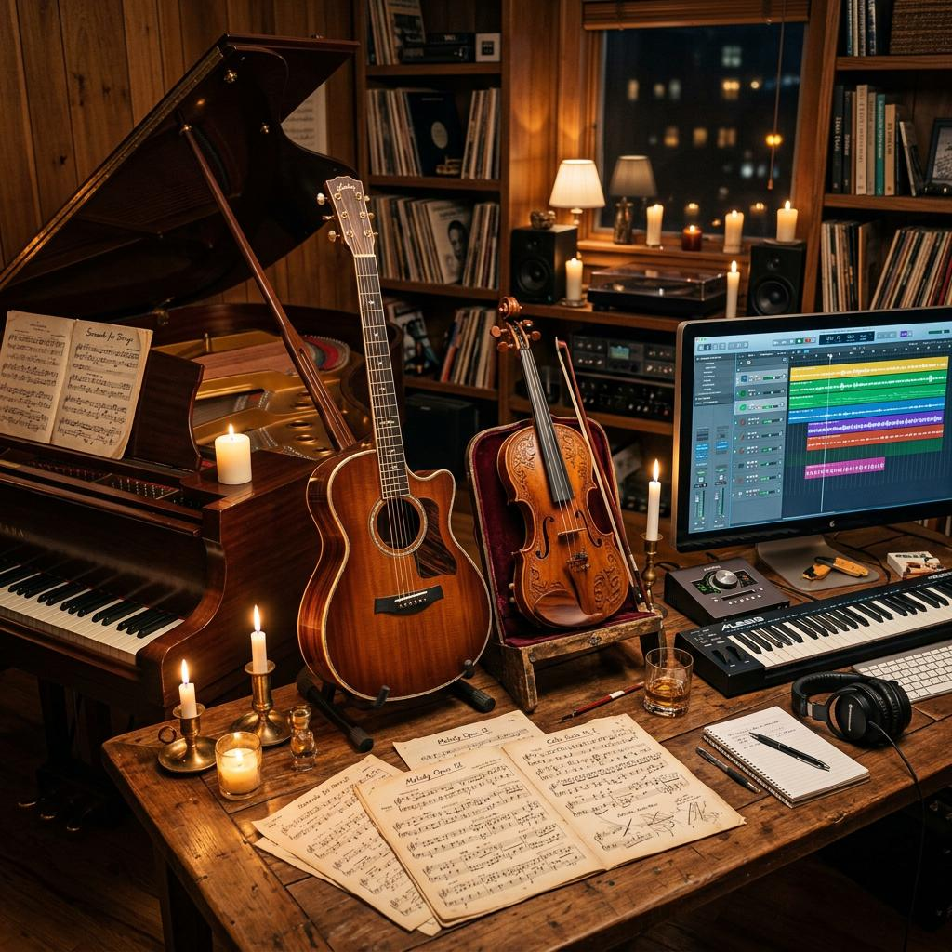
Instrument challenges
Write for unusual or unfamiliar instruments.
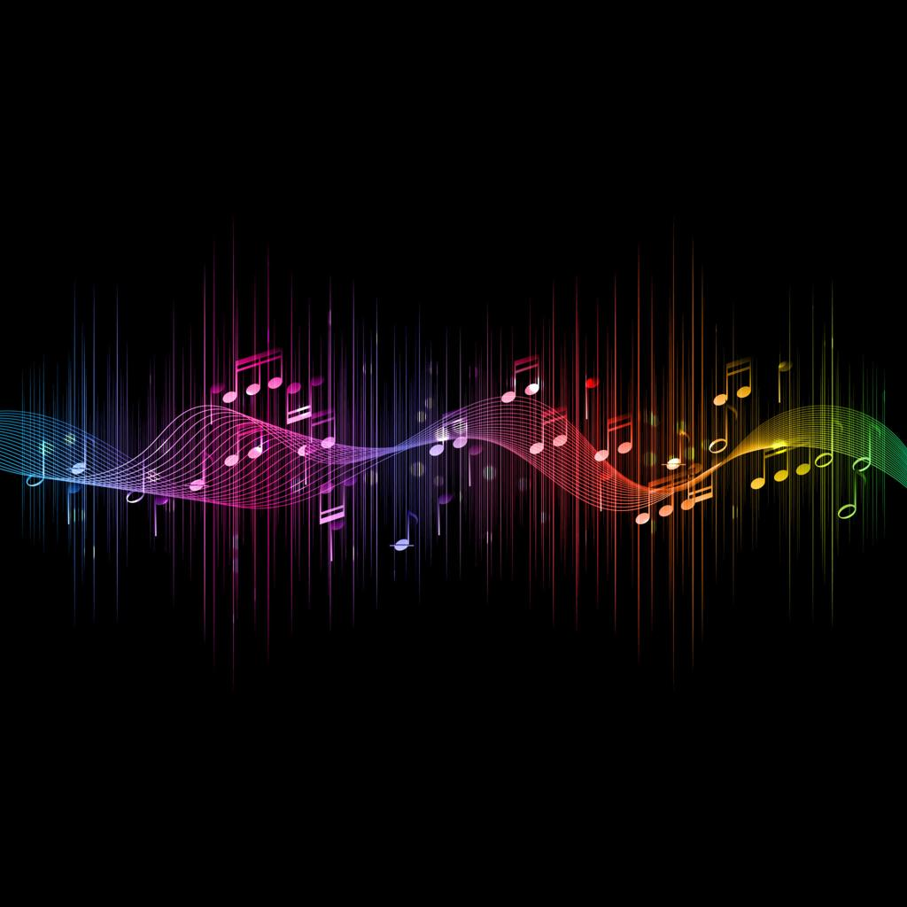
Experimental challenges
Make something strange, unconventional, or unexpected.
Some specific challenge ideas:
- Compose a melody that sounds like a cartoon villain.
- Write something using only black piano keys.
- Make a melody that sounds like it's asking a question.
- Compose a musical idea that gradually gets faster.
- Write a melody that uses a musical palindrome.
- Create something that sounds like an old video game.
- Write a piece that sounds happy but uses a minor key.
- Compose something that could accompany a character walking through a forest.
The more imaginative the prompts, the less the experience feels like a music theory assignment.

5. Make sharing and community fun, not competitive
Wordle's sharing mechanism is one of its strongest features.
You could create something similar, but with actual musical creations.
For example:
- Users can share their daily compositions.
- Every composition has a playback button.
- Users can listen to other people's interpretations.
- Users can leave encouraging comments.
- Users can save their favorite compositions.
- Users can compare how differently people interpreted the same prompt.
One particularly interesting idea:
The Same Prompt, Different Music.
Everyone receives the exact same challenge, but every composer approaches it differently.
Imagine seeing 30 different interpretations of "A Song About Being Lost."
That could be a wonderful way to demonstrate that music composition is subjective and creative rather than something with one correct answer.
I'd avoid leaderboards based on musical quality. They could make beginners feel inadequate.
Instead, consider community recognition such as:
- Most unexpected interpretation
- Most creative use of constraints
- Most interesting melody
- Community favorite
- Most experimental composition

6. Reward participation rather than perfection
I would be careful about implementing a traditional scoring system.
A person shouldn't feel like their composition was bad because it wasn't technically sophisticated.
Instead, reward them for showing up and experimenting.
Some possibilities:
Reward | How it works
Daily streak | Complete a challenge each day
Creative streak | Submit compositions on consecutive days
Exploration badge | Try a new instrument
Rule breaker | Deliberately bend a challenge constraint
Adventurer | Complete an experimental challenge
Collection | Save 10 original compositions
I particularly like the idea of a personal composition journal.
Over time, users could revisit their previous compositions and see how their creativity develops.
That is potentially much more rewarding than a score.

7. Make the actual composition interface simple
This is where I think you can make or break the experience.
You don't want users spending 20 minutes figuring out how to use your website before they even start composing.
I'd consider a very lightweight interface.
Today's composition
4 measures
An example of a simplified composition interface
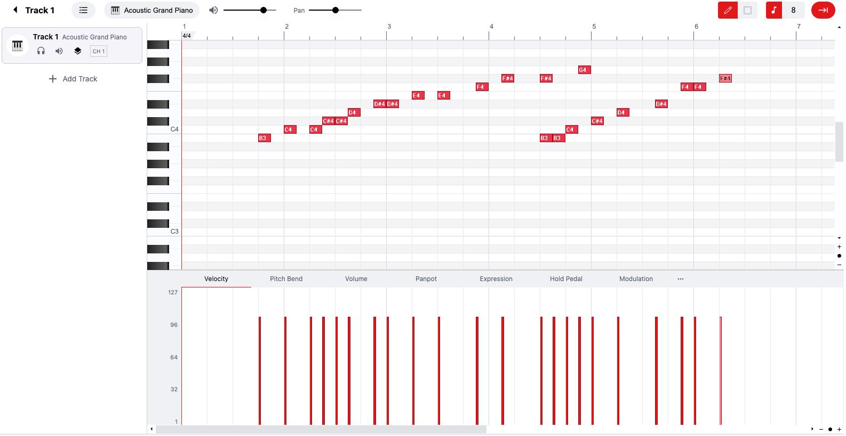
Your tools
♪ Quarter note
♫ Eighth note
𝅝 Whole note
♩ Rest
Your actions
Play composition
Save progress
Illustrative concept, not a functional editor.
Some interface features I'd prioritize:
- Immediate playback: Users should be able to hear what they're creating without complicated setup.
- Undo and redo: Experimentation should feel safe.
- Simple note placement: Clicking a staff position or piano roll should add a note.
- Instant playback: No need to export or compile anything.
- Minimal controls: Only show the tools necessary for that day's challenge.
- Save automatically: Don't let users lose their creative work.
You could also offer two modes:
- Simple Mode: A piano roll, note selection, and playback.
- Advanced Mode: Traditional music notation, more instruments, dynamics, and other compositional tools.
This allows beginners to participate without limiting experienced composers.

8. A feature I particularly recommend: The Inspiration Button
Imagine a user opens the challenge, reads the prompt, and immediately thinks:
"I have absolutely no idea what to write."
Give them an Inspire Me button.
Clicking it might generate one small creative suggestion:
Need a little inspiration?

Try starting with three descending notes.
Imagine someone slowly remembering a distant memory. Perhaps your melody could start high and gradually fall.
This is a suggestion, not a requirement!
Creative spark
You could offer different types of inspiration:
- A suggested opening melody.
- A rhythmic pattern.
- A chord progression.
- A mood or scenario.
- A compositional technique.
The important part is that the suggestion helps users get started without writing the composition for them.

9. My suggested MVP (minimum viable product)
If I were developing this project, I wouldn't try to implement everything immediately.
I'd focus on a small set of features that capture the experience you're going for.
Priority | Feature | Purpose
1 | Daily composition prompt | Gives users a reason to return
2 | Simple music editor | Makes composing accessible
3 | Playback functionality | Lets users hear their creations
4 | Save compositions | Creates a personal music journal
5 | Daily completion streak | Encourages consistency
6 | Share compositions | Encourages community participation
I'd postpone accounts with extensive profiles, advanced notation tools, complex social features, and sophisticated music theory assistance.
You want to validate one central question first:
Will people enjoy creating a small piece of music every day?
If the answer is yes, you can gradually expand the platform.

10. The bigger vision: Change how people think about composition
I think there's a deeper idea worth building into the identity of your website.
Traditional music composition is often presented as something that requires:
- Years of practice.
- Extensive musical knowledge.
- Technical proficiency.
- A high degree of creativity.
- The ability to write something beautiful.
Your platform could challenge that perception.
Instead, communicate ideas like:
- Music doesn't have to be perfect to be worth creating.
- A melody doesn't have to become a song.
- Experimentation is composition.
- There are no wrong answers.
- Five minutes of creativity is still creativity.
I'd even consider making one of your core principles:
"Don't write a masterpiece. Write something today."

A few questions I'd love to explore with you
I think there are three particularly important product decisions that will shape how you build this.
1. Who do you envision using this website?
Complete beginners interested in making music
Experienced musicians and composers
Both beginners and experienced composers
2. How do you envision users actually composing?
Traditional sheet music notation
A piano roll (similar to a DAW)
Both, with a toggle between them
A simplified, game-like music editor
3. What overall experience are you aiming for?
Playful and casual, like Wordle
Educational, helping people learn composition
A creative community and daily artistic outlet
A combination of all three
Anything else you're imagining? (Optional)
I'd especially like to help you develop the actual user experience and daily challenge mechanics. I think there's potential for something genuinely delightful here: a place where people who have always wanted to compose music can finally feel comfortable giving it a try.
While I do think it would be a wonderful idea to allow users to save their short music compositions, I am a beginner computer scientist and will be using Drafter for this program; which I'm not sure has such data saving capabilities, especially across multiple instances of pulling up the program. How would you simplify or change this mechanic to make it more technically accessible while still allowing people to save or keep their music snippets?
I actually think this is a great opportunity to simplify the project without sacrificing what makes it special.
Since you're a beginner computer scientist, I'd recommend changing the idea of a saved composition into a personal collection of daily creations, rather than trying to build a fully fledged music-storage system.
You don't necessarily need user accounts, databases, cloud storage, or complicated backend functionality to give users a satisfying way to keep their work.
Here are a few approaches, starting with the simplest.

1. Let users download their compositions
My top recommendation for a beginner project
Instead of automatically saving compositions to a server, give users a button labeled Save My Creation.
When clicked, it could download a small file containing their composition.
For example:
- day_001.json
- day_002.json
- day_003.json
The file could contain:
- The notes the user selected.
- The rhythm.
- The instrument.
- The date.
- The daily challenge prompt.
This is particularly useful because the composition doesn't have to be stored on your website at all. The user keeps it on their own computer.
You could even give users an option to upload a previously downloaded composition to continue editing it.
Why I like this approach: It introduces users to the idea of saving and retrieving data without requiring you to implement a database or user authentication system.

2. Let users upload their previous creations
Drafter actually has a feature that makes this approach particularly practical: FileUpload.
You could create a My Music page with two options:

My Music Collection
Keep your musical ideas together.
Import an old creation
Upload a composition file you previously downloaded.
Export today's creation
Download your current musical idea to your computer.
This gives users a way to maintain a collection of compositions without you needing to maintain that collection on a server.
The workflow would be:
- User completes the daily challenge.
- User downloads their composition.
- A few days later, they return to your website.
- They upload their previous composition.
- Your website reads the file and displays the composition again.
Drafter's documentation specifically describes this download-and-upload approach. It supports text files, which makes JSON a reasonable format for your project.
Drafter Documentation

3. Give users a personal composition journal
I'd also change the way you present the saving feature.
Rather than trying to build a complicated account-based music library, create a page called My Composition Journal.
It could look something like this:

My Composition Journal
3 creations
Day 001 — Nostalgia
October 29
My first melody
4 measures · Piano
Saved
Day 002 — A Rainy Day
October 30
Rain on the Window
4 measures · Piano
Saved
Day 003 — Unexpected Rhythms
October 31
Little Experiment
2 measures · Percussion
Saved
Illustrative journal design. Compositions are represented by downloadable files.
The journal could simply be a visual representation of compositions the user has imported during their current visit.
This is an important distinction: you can build the appearance of a music collection without initially building a permanent music database.

4. One important Drafter limitation to understand
There's something important about Drafter that affects your design.
Drafter uses an application State dataclass to remember information as users navigate between pages. However, that state is temporary.
According to its documentation:
- Information survives navigation between pages.
- Each visitor has their own independent application state.
- Reloading or closing the browser resets that state.
- Drafter doesn't automatically provide a permanent database.
- Drafter Documentation
- +2
So, for example, you could store a user's current composition in State, but you shouldn't assume it will still be there when they return tomorrow.
Drafter's Download and FileUpload features are a much more accessible starting point.
Drafter Documentation

5. My recommended development roadmap
I'd implement the saving functionality in stages:
Stage | Feature | Difficulty
1 | Save current composition as a downloadable file | Easy
2 | Upload previously saved compositions | Easy–moderate
3 | Display imported compositions in a journal | Moderate
4 | Export and import an entire journal as one file | Moderate
5 | Automatic saving across visits using browser storage | More advanced
6 | User accounts and cloud-based music libraries | Advanced
One additional idea: Eventually, you could let users download their compositions as MIDI files, which they could open in other music software. But I wouldn't make that a requirement for your initial version.

My overall recommendation
Best fit for your first version
I'd build your initial website around three core mechanics:
- Compose: Users create a small musical snippet in response to the daily prompt.
- Download: Users can save their composition to their own computer.
- Revisit: Users can upload their previous compositions to listen to or edit them again.
This keeps your project manageable while preserving one of the most rewarding aspects of the experience: watching your collection of musical ideas grow over time.
And remember, you aren't abandoning the idea of a personal composition library. You're simply implementing it in a way that matches your current programming abilities.
One last piece of advice: Don't let the saving feature become a bigger project than the composition experience itself. The heart of your website is encouraging people to make music every day. Everything else should support that goal.

Part 8: Submit
In Google docs, with this document open, please click on File > Download > Microsoft Word (.docx), and make sure you put that download somewhere you can find it again. Then, upload it to the Canvas assignment about selecting or brainstorming your final project.

When you're done with this assignment, review this page of the Drafter documentation to better prepare for the next step.

